CALCULATION OF DELAY, JITTER AND APPLICATION THROUGHPUT USING PIVOT TABLES IN EVENT TRACE FILE

- Enable Event trace and after simulation select Event Trace in the Simulation results window. Event tracing is available only in NetSim standard and Pro versions as of v10.
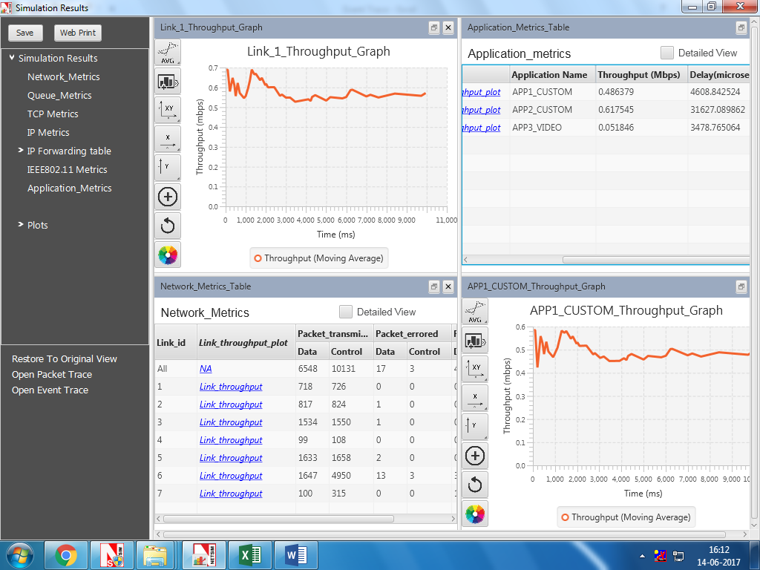
- Click on Pivot Table in INSERT tab

- Then a window named Create Pivot Table pops up which automatically selects the entire table, then click OK button. In case the entire table isn’t selected please enter the range such that all rows are selected.

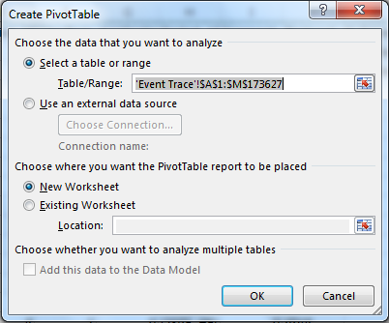

- A blank PivotTable and Field List will appear on a new worksheet.

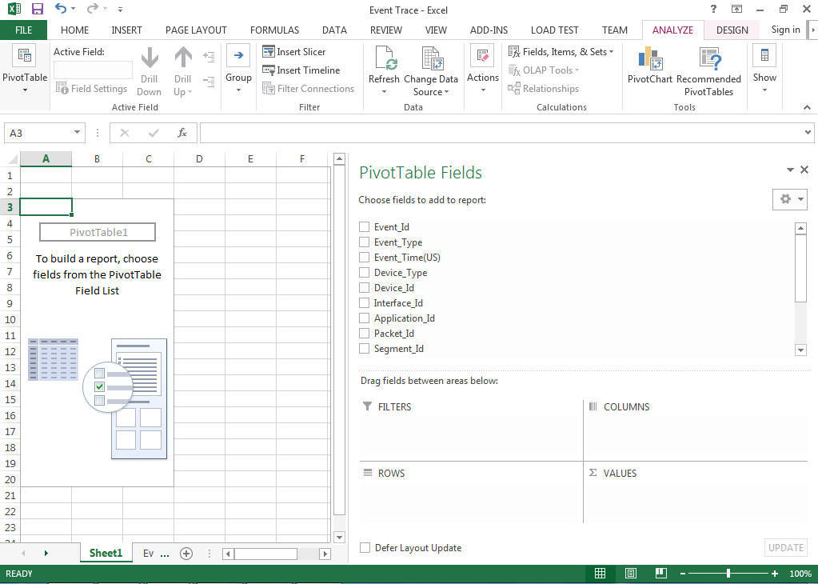

- Once you create a PivotTable, you'll need to decide which fields to add. Each field is simply a column header from the source data. In the PivotTable Field List, check the box for each field you want to add.

Application Delay Analysis:
- Drag and drop the Event_Type, Protocol_Name Fields into FILTERS, Packet_Id into ROWS and Device_Id into COLUMNS.
- Drag and Drop Event_Time Field into VALUES twice, then both will show Sum of Event_Time. Recheck that you have dropped the Event_Time field twice.
- Click on the second Event_Time field in the VALUES and select the Value Field Settings.

- A window named Value Field Settings opens then select Count option and click OK button

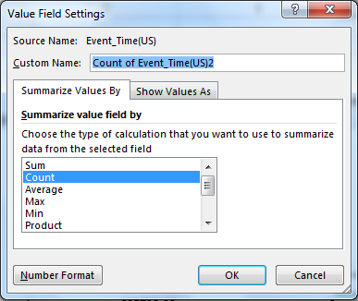

- Then finally the Pivot Table Fields will be as shown below.
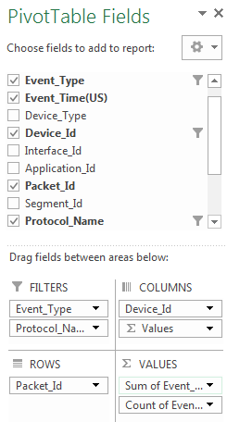
- In the Event_Type select APPLICATION_IN and APPLICATION_OUT, Protocol_Name select APPLICATION and in Column Labels select the Source_Id and Destination_Id. In our example source node ID is 1 and destination node ID is 10
S

And the Pivot Table created will be as shown (1 in the table is Source_Id and 10 is the Destination_Id)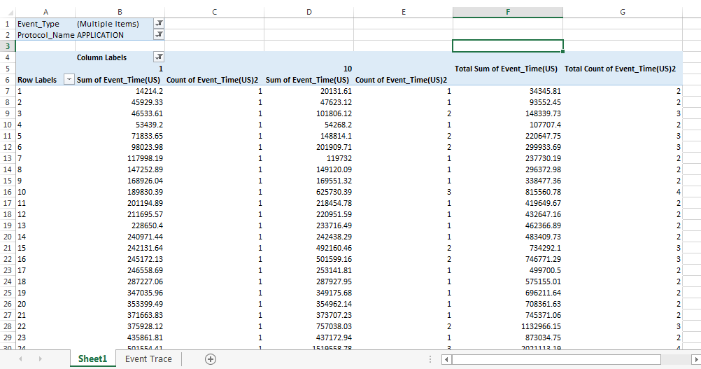
- Select the entire empty column H then and enter the formular =IF(AND(LEN(A1), INT(A1)=A1),F1-G1*B1) in function and press CTRL+ENTER
F column is Total Sum of Event_Time, G Column is Total Count of Event_Time, B Column is Sum of Event_time(µs) of the Source.

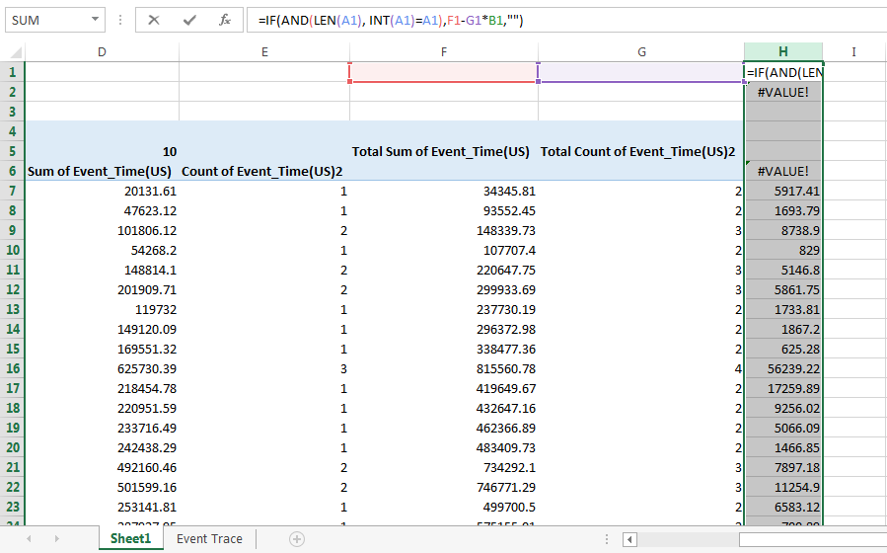
App Delay = $\frac{Sum of the Delays of the sucessfully received application data packets by the destination}{Total number of sucessful appplication data packets received by the destination}$

Note: If the packet size is > 1500 then fragmentation occurs and the packet is received as multiple segments. In NetSim the destination counts each segment as different packet.
Then in an empty cell enter
=SUMIF(H:H,">0")/GETPIVOTDATA("Count of Event_Time(US)2",$A$4,"Device_Id",10)
where
GETPIVOTDATA ("Count of Event_Time(US)2",$A$4,"Device_Id",10) gives the total number of packets received by the destination(in this case 10).
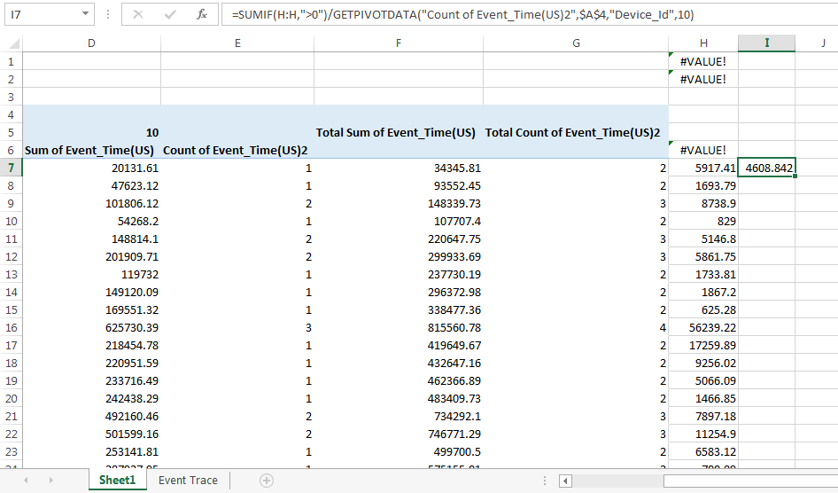
This will give the exact Application Delay
Compare with the Delay in Application_Metrics_Tables and it would exactly match. There might be slight difference in the decimals due to Excel’s round offs.

Application Jitter Analysis
In NetSim ‘jitter’ is defined as the variance of delay. Variance is statistically defined as the square of deviation from the mean.
(Note: This calculation is only valid only when there is with no packet segmentation. This means that all Packet Sizes should be less than 1500B)
- For Jitter Calculation Pivot table Fields should be as shown below
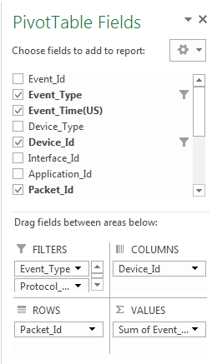
FILTERS to have of Event_Type, Protocol_Name, COLUMNS to have Device_Id, ROWS to have Packet_Id and VALUES to have Event_Time (Note that Event_Time is added only once and not twice as was done for delay calculation)

- Then select any cell of Destination node column and right click and select Show Values As option, it dropdown a list in which you select Difference From option.
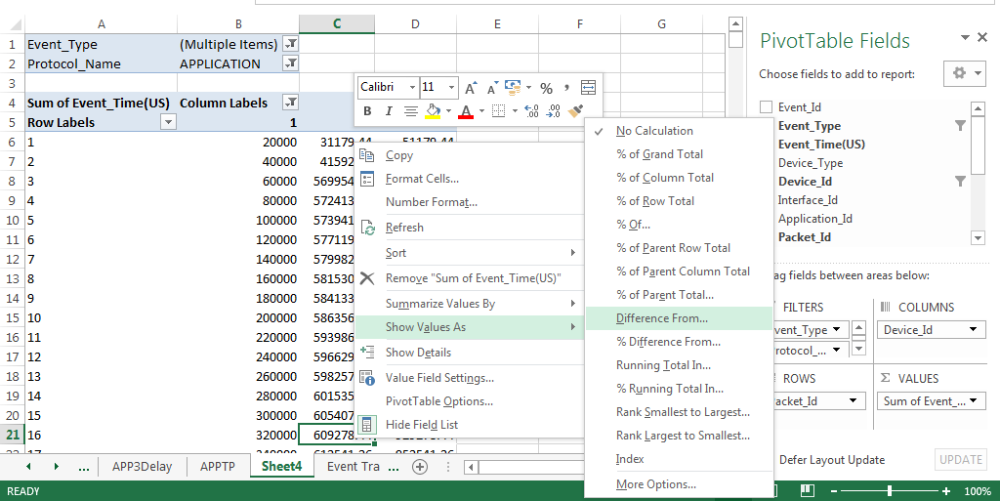
Then it opens a window named Show Values As in that select Base Field as Device_Id Base Item as the Source_Id (1 in this case) and click OK button.

Then the Pivot Table will look like this

And the destination node column shows the delay of each packet.

- Place the mouse cursor on the top of Destination Id then left click it will automatically selects the rows of the destination Id, then select the Name Box and name the row.
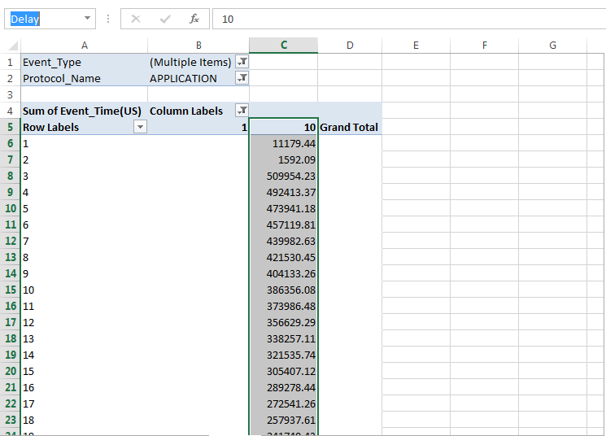

Then in an empty cell type the following formula and press enter
=ADDRESS(ROW(Delay)+1,COLUMN(Delay)) &":"& ADDRESS(ROW(Delay)+ROWS(Delay)-2,COLUMN(Delay)+COLUMNS(Delay)-1)
This will give you the Row Address
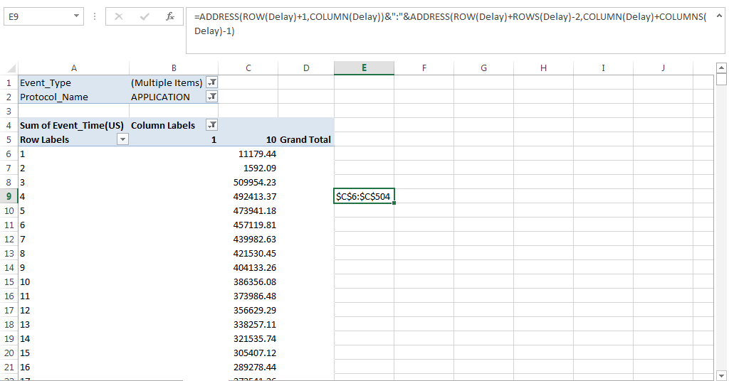
Then enter =VAR.S(Row Address), where the Row Address is one that you got in the previous step.
This will give you the Application Jitter.
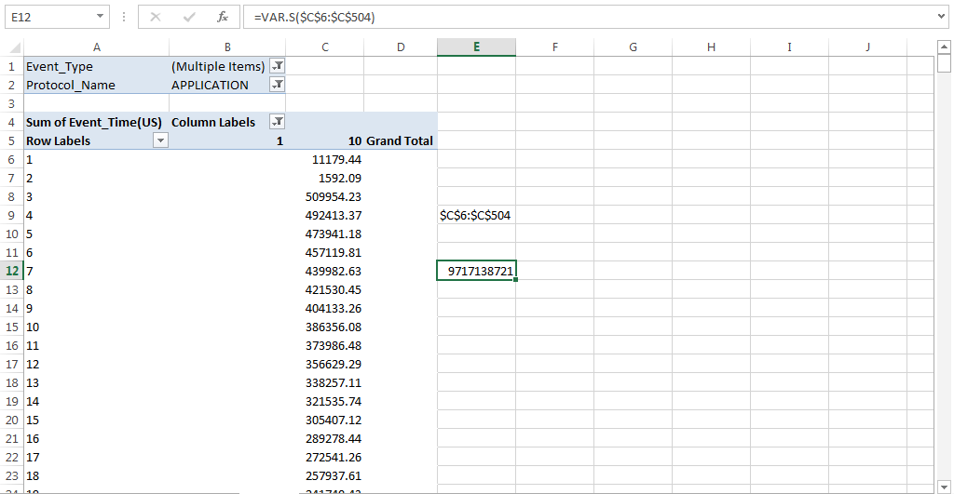

Application Throughput Analysis:
- For Application Throughput drag and drop Event_type, Protocol_Name Fields in FILTERS, Device_Id in ROWS, Packet_Size(Bytes) into VALUES. Change the Value Field Settings of Packets_Size(Bytes) to SUM as mentioned in Delay Analysis.
Then Select the Event_Type as APPLICATION_IN, Protocol_Name as APPLICATION and Device_Id as the Destination (in this case 10).

- App Throughput = $\frac{Total Payload application succesfully received by the destination}{Simulation time}$

- Then in an empty cell type =GETPIVOTDATA("Packet_Size(Bytes)",$A$4)*8/10000000
This give the Application Throughput in Mbps (Multiplied by 8 to convert Bytes to bits, and divided by 100000 to convert into Mega)

Compare with the Application throughput in the Application_Metrics_Table

